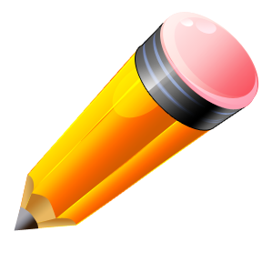
Author’s Name: ____________________________________________

Peer Editor’s name: _________________________________________ Editing
Writing piece: ___________________________________________________________ Checklist

Self-Edit check |  |  |  | Peer Edit check and comment
 | Check for capital letters at beginning of sentences and proper nouns. | Capitalization | Check for capital letters at beginning of sentences and proper nouns. | _____
 | Sentences have a noun and verb. I use homophones correctly. | Usage | Sentences have a noun and verb. I use homophones correctly. | _____
 | Read your piece aloud to see where to stop or pause for periods, question marks, exclamation points and commas. | Punctuation | Read the writer’s piece aloud to see where to stop or pause for periods, question marks, exclamation points and commas. | _____
 | I checked for misspellings and words that do not look right. | Spelling | I checked for misspellings and words that do not look right. | _____

