***Comprehension Strategies***



***Noticing*** = *Seeing, realizing*

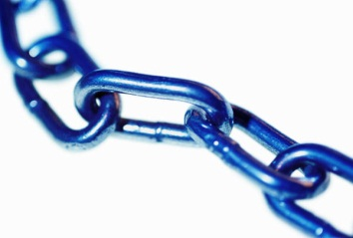C:\Users\Kristen\AppData\Local\Microsoft\Windows\Temporary Internet Files\Content.IE5\ISKXK1WB\MC900441972[1].wmf

***Connecting*** =

How does it relate to me?



***Predicting*** = *Guessing*

“What will happen next?”

C:\Users\Kristen\AppData\Local\Microsoft\Windows\Temporary Internet Files\Content.IE5\PRTR4LY6\MC900390846[1].wmf

***Visualizing*** = *Picturing in your mind*

What do I see? Hear? Feel?

***C:\Users\Kristen\AppData\Local\Microsoft\Windows\Temporary Internet Files\Content.IE5\ISKXK1WB\MC900078711[1].wmf***

***Questioning*** = Wondering

Who? What? Where? When? Why? How?

C:\Users\Kristen\AppData\Local\Microsoft\Windows\Temporary Internet Files\Content.IE5\R5ABDGX0\MC900233920[1].wmf

***Inferring*** = Figuring out

Evidence **+** reasoning **=** idea